Sample Super Store Dashboarding

1)Select Sample Superstore as Dataset
- Use Sample Superstore Dataset
- Select Data
- Use Group by from Data Source Table on a Folder to create a folder to segregate the required data for Customer Name and Order ID in order to organize the data thoroughly.
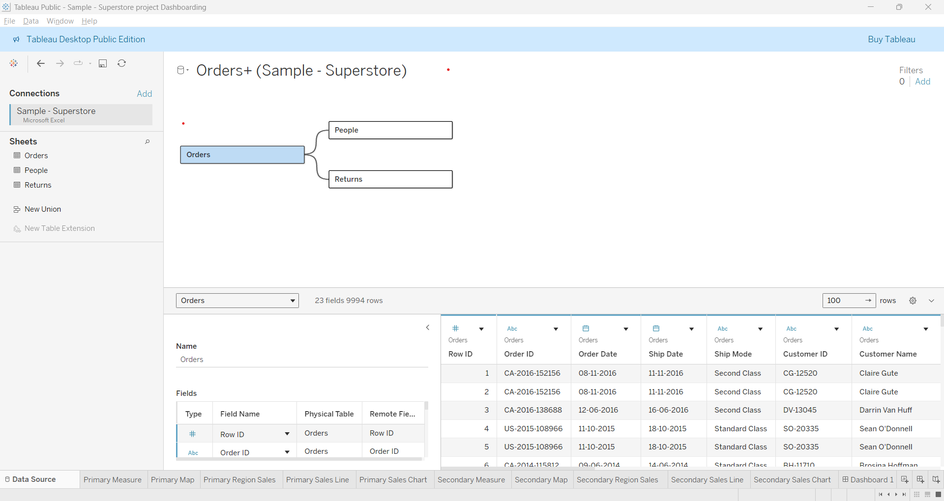
2)Create a hierarchy called Location for the variable Country.

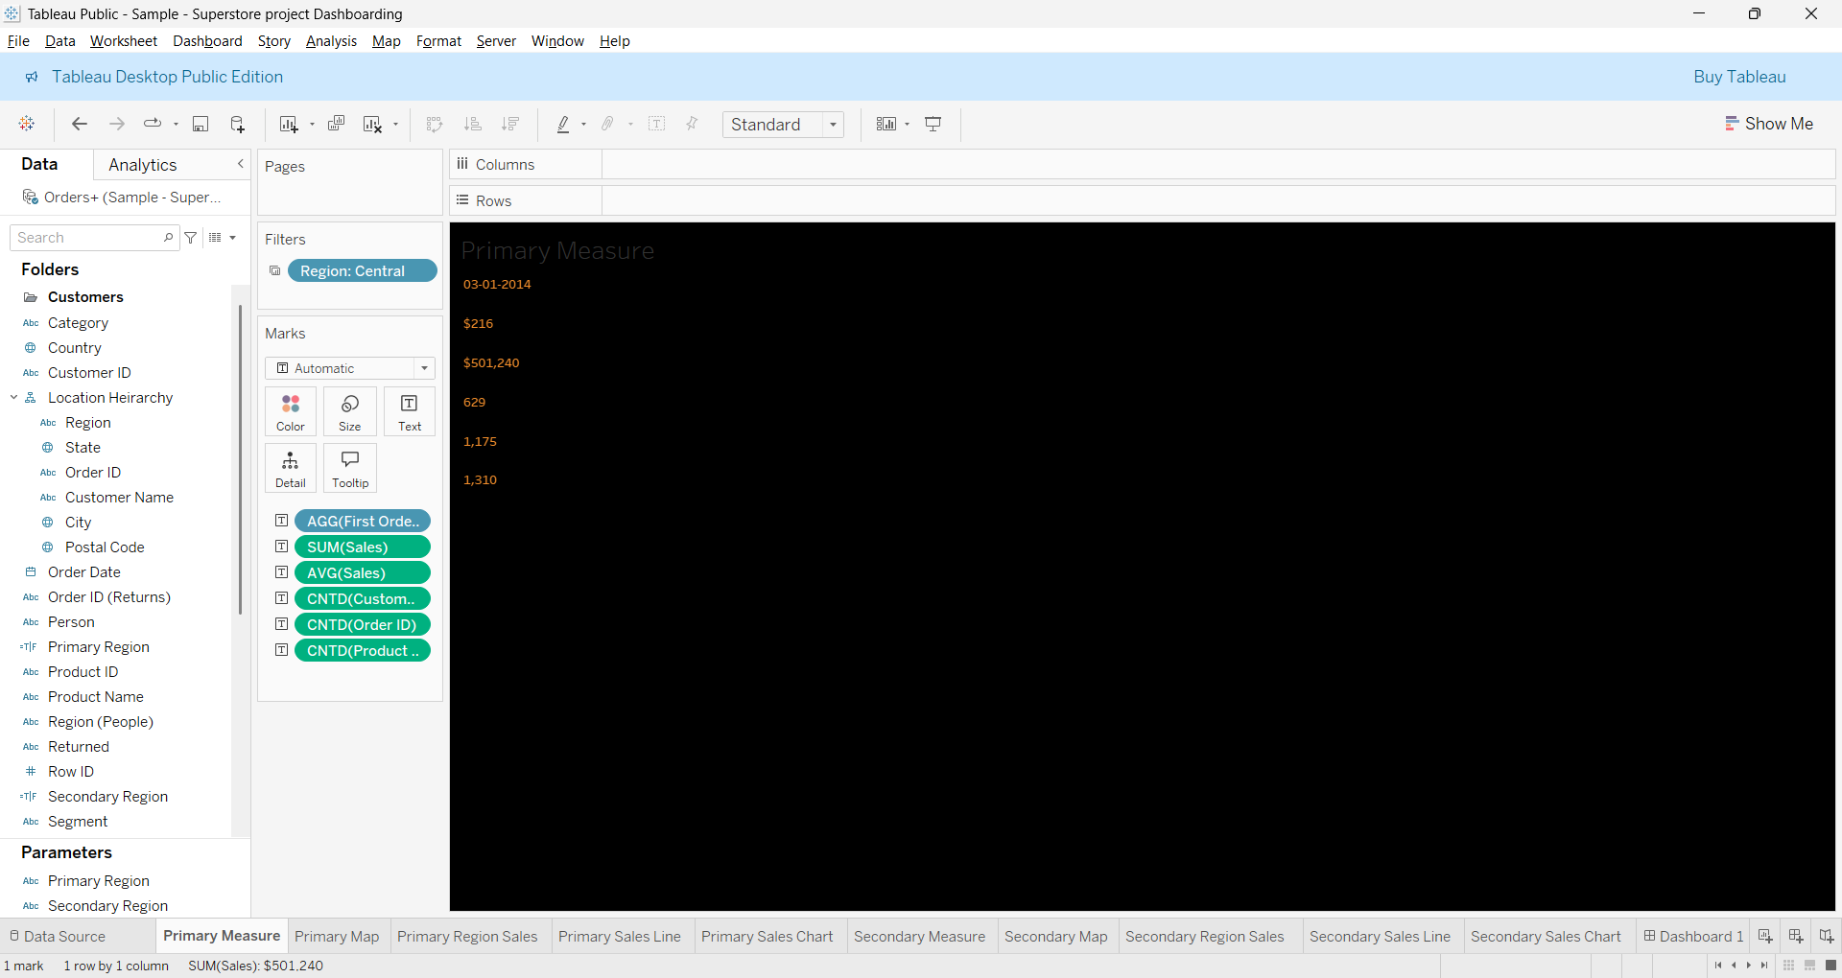

3)Create two parameters: Primary Region and Secondary Region with all regions listed in them. Here, primary and secondary region are the two regions where the sales are being compared.
- Create Parameters for Primary Region and Secondary Region
- Create a Calculated Field for both Primary Region and Secondary Region
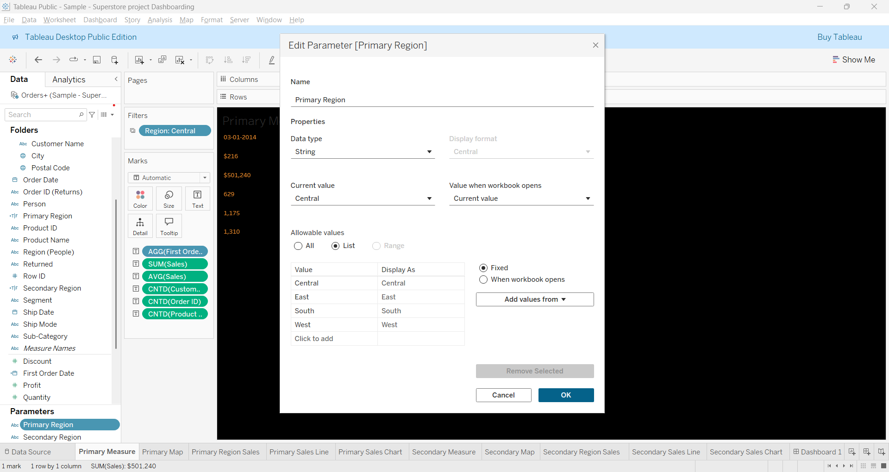
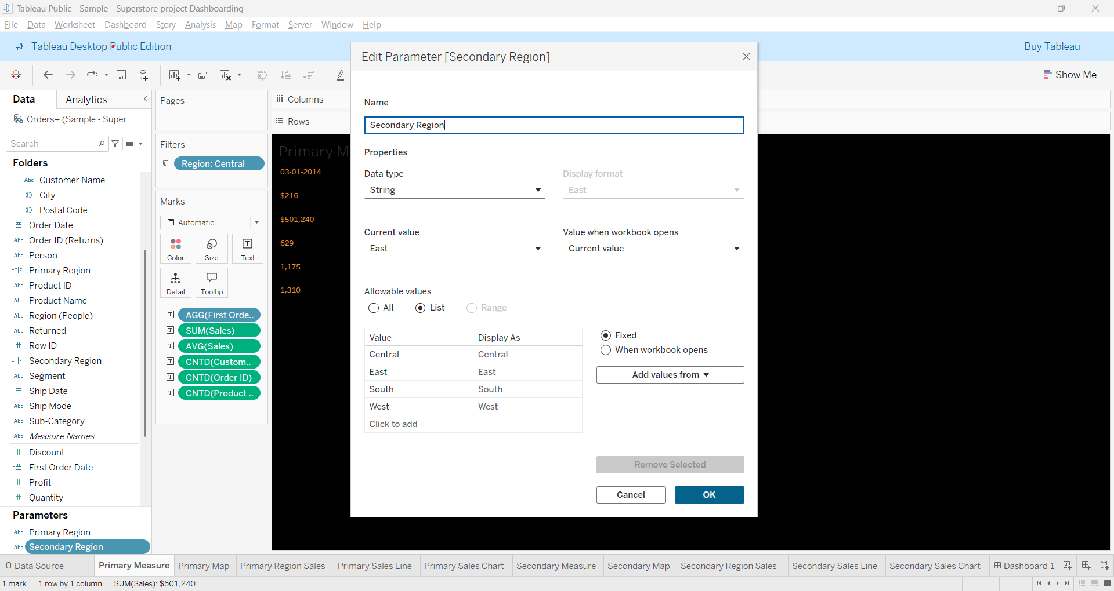

4) Create a First Order Date
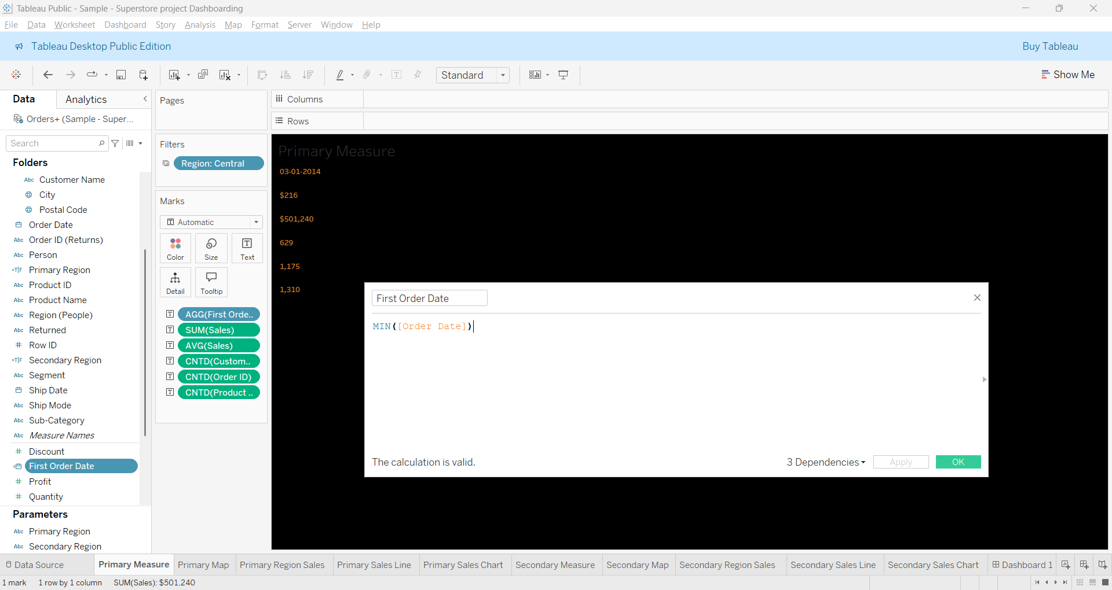
5)Create a dashboard
